Common Language for Experiential Education

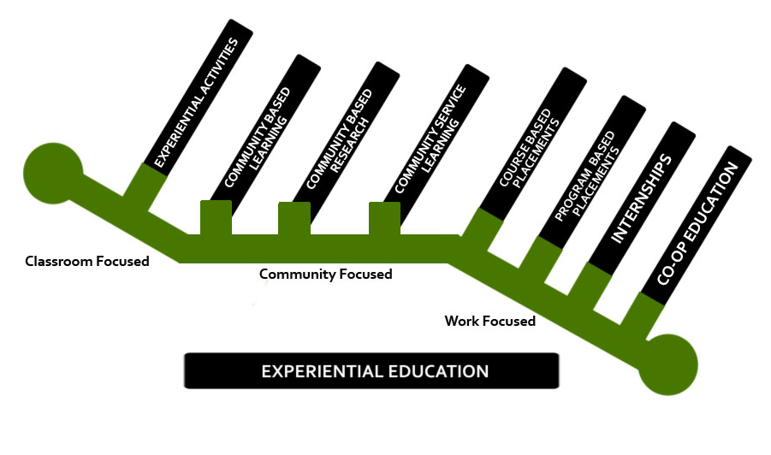

Definition of Experiential Education (EE)

"EE is an approach to learning that bridges theory and practice by providing students with concrete applied practical experiences and then helping them to reflect on their experiences using the theoretical knowledge they have learned (York’s White Paper Companion, 2010:38)."

Definition of Structured Reflection
Structured reflection is any planned activity or exercise that requires students to refer back and critically examine the concrete experience in light of existing theory and/or what is being covered in the course. For example, following a concrete experience, students may have to: explain why certain events occurred, or justify the necessity of certain procedures, or consider the experience from multiple perspectives or challenge their assumptions or beliefs. The specific reflective learning exercise will depend upon the intended learning outcome(s) for the students.

Note: It is important that steps are taken to ensure that degree programs incorporate EE across a range of courses at different levels. Early experiences in developing reflective thinking and collaborative learning through classroom-focused activities serve as building blocks for community and work-focused opportunities later in the student’s degree program, preparing students to experience deeper learning and adapt to workplace teams. All EE activities should be fully integrated into the course with explicit links to student learning outcomes (and course assessment strategies).

EE STRATEGIES
- Classroom-focused
- Community-focused
- Work-focused (work-integrated learning)

1. CLASSROOM-FOCUSED EE: Students are exposed to concrete learning activities in the classroom (physical or virtual, e.g., online) that require them to reflect on what they have experienced in relation to concepts/theories being covered in the course. All classroom focused EE strategies contribute to addressing student learning outcomes.

1. a) Experiential Activities: This experiential education strategy allows students to apply theory and course content to concrete experiences that encourage reflection and conceptualization. These experiences not only encourage active learning but also include structured reflection, encouraging the student to refer back to the experience in an effort to make sense of it by considering relevant course material. These concrete experiences could take place within the classroom or outside the classroom through observation, reflection and practical applications. They are combined with purposeful reflective learning exercises such that the experience is considered in relation to the concepts/theories addressed in the class.

Wherever they occur, they count as classroom-focused EE because they prioritize student learning outcomes over reciprocal impact within community.

Key features:

How do students engage in EE? Within the classroom through the use of guest speakers, rehearsals and performances, role playing, visual media, case studies, simulations, workshops and laboratory courses, course-based research or outside of the classroom through interviews with professionals in a particular field, participation in community events, observations of lived experiences that correlate with topics under study, and visits/field trips to sites that are of particular relevance to certain disciplines.

To what extent are community partners engaged/involved? As guest speakers/participants, transferring knowledge and/or subject matter expertise within the classroom or as bystanders being observed within the community.

Is priority given to student learning outcomes or community partner needs? Student learning outcomes for the course are the priority with this type of EE.

How long and how frequently do these experiences occur? Experiential Activities take place throughout the length of the course. Experiential activities make up a significant portion of the course.

How are students remunerated? Students receive academic credit for Experiential Activities. Experiential Activities are unpaid.

2. COMMUNITY-FOCUSED EE: Students have the opportunity to connect course material with experiences that occur through interactions with community partners that can take place in the classroom or in the community. These connections tend to occur in groups/teams focused on a specific project. Reflection remains a key element, which requires students to link the concrete experience with the students’ understanding of theory. All community-focused EE strategies contribute to addressing both student-learning outcomes and identified community needs. “Community partners” can refer to small-scale local entities from the public or private sector to large-scale local, national, trans-national, entities such as corporations, government and non-governmental organizations. Categories of community focused EE include the following.

2. a) Community Based Learning (CBL) is a form of experiential education that is interactive with the community but takes place within the classroom. Community partners are invited into the classroom to present pre-defined problems, questions or issues to be explored and analyzed. Students are exposed to scenarios, situations, problems and issues described by the community partners, to which students apply their developing knowledge and reflect on how the actual experience informs their learning. The CBL project benefits both student learning and the community partner.

Key features:

How do students engage in EE? Students are exposed to scenarios, situations, problems and issues presented by community partners within the classroom, to which they apply their developing knowledge.

To what extent are community partners engaged/involved? The experience requires consultation between the Course Director and the community partner and clarification of expectations in terms of what students can deliver. Community partners may participate in the assessment of the students’ work if it involves, for example, reports or presentations.

Is priority given to student learning outcomes or community partner needs? A CBL project is created/structured so that it benefits both student learning and the community partner.

How long and how frequently do these experiences occur? CBL projects can vary in length, from a project that takes place over a few weeks to a project that spans the duration of the course. During CBL students have the ability to work remotely from the organization.

How are students remunerated? Students receive academic credit for Community Based Learning. Community Based Learning activities are unpaid.

2. b) Community Based Research (CBR) Students are given the opportunity to work on a research project that is part of a course and has been co-created and developed through the collaboration between a community partner and a researcher (e.g., course director). Not only must the CBR activity satisfy the student learning outcomes of the course but it must also satisfy the needs of the community partner. It is: practically relevant to the community; collaborative and action oriented. The CBR project may take the form of an applied independent research study or thesis.

CBR activities are normally completed within the duration of a full-year 6.0 credit course (i.e., 24 weeks), though in some cases these activities are completed in a 3.0 credit course. Community partners often participate in the assessment of the students’ work and benefit from this work which may take the form of project reports, presentations, or recommendations.

Key features:

How do students engage in EE? Students may engage by working on a research project developed through the collaboration of a community partner and a researcher.

To what extent are community partners engaged/involved? The experience normally requires a formal agreement between the researcher and the community partner outlining items such as: research ethics, how data will be shared, stored, etc.

Is priority given to student learning outcomes or community partner needs? A research project is created/structured so that it benefits both student learning and the partner organization.

How long and how frequently do these experiences occur? CBR can vary in length, from a research project that takes place over a few weeks to a research project that spans the duration of the course.

How are students remunerated? Students receive academic credit for Community Based Research. These activities are unpaid.

2. c) Community Service Learning (CSL) This is a form of experiential education where "students engage in activities that address community needs together with structured opportunities intentionally designed to promote intentional learning goals" (www.nsee.org). CSL takes students into the community as part of the learning experience. The real-life situation provides the concrete experience for students to apply their developing knowledge and skills and to deepen their understanding by reflecting on their learning. CSL is often used as a strategy to address not only course-based material but also to help students develop an awareness of the value of civic engagement.

Note: There are forms of Community Service Learning that are co-curricular in nature. They often include volunteering opportunities for students. In such forms, CSL is not-for-credit. For our purposes, we are addressing only academically embedded CSL.

Key features:

How do students engage in EE? Students may engage by providing direct service (other than research) to the community or by taking on a project defined by a community organization.

To what extent are community partners engaged/involved? Community partners often participate in the assessment of the students and may benefit from this work which may take the form of service and/or project reports, presentations, or recommendations. The experience may require a formal partnership by way of an affiliation agreement between York University and the partner organization outlining items such as obligations of York University, obligations of the partner organization, insurance considerations and other specifics pertaining to the activity.

Is priority given to student learning outcomes or community partner needs? A service learning project or opportunity is structured so that it benefits both student learning and the partner organization.

How long and how frequently do these experiences occur? CSL can vary in length, from a project that takes place over a few weeks to a project that spans the duration of the course. During CSL students work at the community partner’s site and keep regular hours.

How are students remunerated? Students receive academic credit for Community Service Learning. Community Service Learning activities are unpaid.

3. WORK-FOCUSED EE: Students have the opportunity to develop competencies and skills and augment the theories/concepts learned in their degree programs by getting hands-on work experience within organizational environments. Reflection remains a key element, which requires students to link the concrete experience with the students’ understanding of theory. All work focused EE strategies contribute to addressing degree level expectations, in particular, the student’s ability to demonstrate autonomy and professional capacity. Categories of work focused EE include the following.

3. a) Course-based Placements (CBP) This is a form of experiential education where students have the opportunity to develop competencies and skills and augment the theories/concepts learned in their course by getting hands-on experience within organizational environments. The learning emphasizes career exploration and employability/professional skills development (HECQO, Practical Guide for WIL, 2016). (e.g. Communication, Disaster & Emergency Management, History, Portuguese, Public Policy & Administration, Work & Labour Studies and Urban Studies). Students must complete this placement in order to complete/pass the course. They receive course credit but are not (generally) paid.

Key Features:

How long do students engage in EE? Students engage in activities where they practice the discipline or course specific competencies and skills in an authentic work context.

To what extent are community partners engaged/involved? The experience requires a shared understanding between the Course Director and the partner organization of expectations and student capabilities; as well such placements require a formal agreement between York University and the placement site to address various issues such as confidentiality, insurance coverage, risk management etc.

Is priority given to student learning outcomes or community partner needs? The experience is structured so that it benefits both student learning and the partner organization.

How long and how frequently do these experiences occur? The placement is usually part-time and requires students to periodically return to class to share their experiences and make meaning of their time with the community partner. The length of the course-based placement typically last the duration of the course.

How are the students remunerated? Course-based placements are required as part of the course. Students are evaluated (e.g. report, sponsor evaluation, self evaluation, etc.) on their placement performance as part of their final grade in the placement course. Placements are unpaid experiences.

3. b) Program-based Placements (PBP): Students are given the opportunity to develop competencies and skills in organizational work environments that augment the theories/concepts learned in academic program settings. Students apply theories and concepts from their program work in a practice-based work environment and reflect upon their actions. Students engage in activities where they practice the discipline or program specific competencies; they receive program credit for doing so but (generally) are not paid. Program-based placements are also known as fieldwork, field placements or practica (e.g. Education, Nursing, Social Economy or Social Work).

Key features:

How do students engage in EE? Students engage in work activities where they practice the discipline or program specific competencies and skills in an authentic work context.

To what extent are community partners engaged/involved? The experience requires a shared understanding between the academic program and the community partner/placement site of expectations and student capabilities; as well, such placements require a formal agreement between York University and the placement site to address various issues such as confidentiality, insurance coverage, risk management etc.

Is priority given to student learning outcomes or community partner needs? Work is structured so that it benefits both student learning and the partner organization.

How long and how frequently do these experiences occur? The program-based placement experience may be full-time or part-time and requires that students periodically return to class to share their experiences and make meaning of their time 'in the field’. The length of program-based placements can vary depending on the degree requirements for the practicum.

How are students remunerated? Degree-based placements are required as part of the degree program. Students are evaluated (e.g. report, sponsor evaluation, self-evaluation, etc.) on their program-based placement performance as part of their final grade in the program-based placement. Program-based placements are typically unpaid work experiences.

3. c) Internships provide students with the opportunity to augment the theories/concepts learned throughout their degree and develop competencies and skills through hands-on work experience related to their field of study. Internships are paid, full-time, supervised work experiences in which learning is assessed via the student reflecting on their internship experience in the workplace and writing a work term report, which is then reviewed and graded by the faculty supervisor. Internships are generally associated with academic programs that include a practice, service or professionally oriented applications. Unlike co-op students participating in internships students do not alternate work experiences with academic terms.

Key features:

How do students engage in EE? Students engage in work activities where they practice the discipline or course specific competencies and skills in an authentic work context.

To what extent are community partners engaged/involved? The work experience requires some form of learning agreement that is shared by the employer, the faculty supervisor and the student. The student's work progress is monitored by York University and work performance is supervised and evaluated by the partner organization.

Is priority given to student learning outcomes or community partner needs? Supervised work is structured so that it benefits both student learning and the partner organization.

How long and how frequently do these experiences occur? Internship work terms typically take place after a student’s third year of study for 4, 8, 12 or 16 months of consecutive work. Students must return to class for their final year of study.

How are students remunerated? Internships are (generally): zero-credit, optional, one-time work assignments. Students receive a transcript notation - typically a faculty supervisor assigns a pass/fail. Internships are paid work experiences.

3. d) Co-operative Education Programs: Co-op programs provide students with the opportunity to integrate their classroom learning with hands-on work experience related to their field of study in which they alternate periods of paid, full-time, supervised work experiences with their academic terms. According to the Canadian Association for Cooperative Education (CAFCE; http://www.cafce.ca/en/coop-defined), a co-op program is one which alternates periods of academic study with periods of work experience in accordance with the following criteria:

- “each work situation is developed and/or approved by the co-operative educational institution as a suitable learning situation;
- the co-operative student is engaged in productive work rather than merely observing;
- the co-operative student receives remuneration for the work performed;
- the co-operative student's progress on the job is monitored by the co-operative educational institution;
- the co-operative student's performance on the job is supervised and evaluated by the student's co-operative employer; and
- time spent in periods of work experience must be at least thirty per cent of the time spent in academic study.”

Co-operative education programs can be either for-credit or zero-credit endeavours, and are generally noted on the transcript and degree. Co-operative student positions are most often 4 to 8 months in duration, with a commitment of 12-16 months in total over the course of the degree. Given the alternating nature of work and study terms, co-operative education programs tend, in most cases, to necessitate alignment with a trimester system.

Key features:

How do students engage in EE? Students engage in work activities where they practice the discipline or course specific competencies and skills in an authentic work context.

To what extent are community partners engaged/involved? The work experience requires some form of learning agreement that is shared by the partner organization, the faculty supervisor and the student. The student's work progress is monitored by York University and work performance is supervised and evaluated by the partner organization.

Is priority given to student learning outcomes or community partner needs? Supervised work is structured so that it benefits both student learning and the partner organization.

How long and how frequently do these experiences occur? Co-op work terms typically take place after a student’s second year of study for 4-8 months of consecutive work with a commitment of 12-16 months in total over the course of the degree (or 30% of time spent in academic study). Students alternate periods of academic study with periods of work experience.

How are students remunerated? Co-operative education programs can be either for-credit or zero-credit endeavours, and are generally noted on the transcript and degree. Co-ops are typically paid work experiences.

As indicated by the Center for Community based research (http://www.communitybasedresearch.ca)
Best practices dictate that critical reflection about the concrete activity informs the report.

